TRAFFIC MANAGEMENT SYSTEM

TEAM MEMBER

963321106025: S.Barath

Phase 3 project submission

Project: Traffic management system

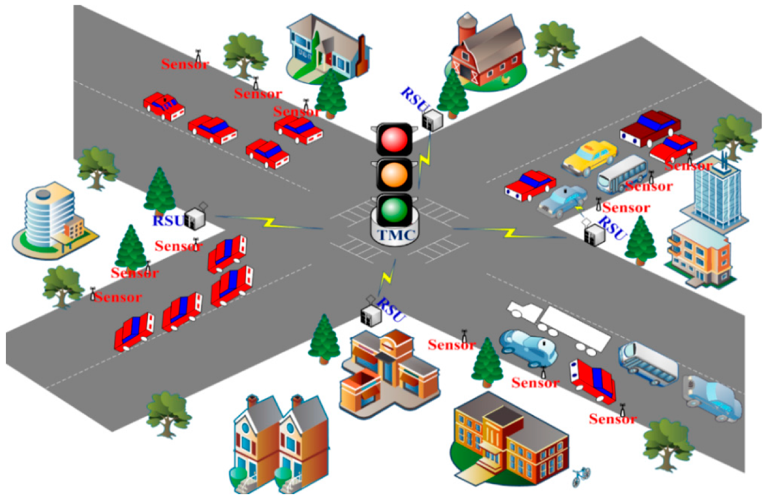

**Development part -1**

**1)Objectives:**

The objectives of a traffic management system are to improve the efficiency, safety, and sustainability of a transportation network. These systems use various technologies and strategies to achieve these objectives. Here are some of the key objectives of a traffic management system:

1. **Reduce Congestion:** One of the primary objectives of a traffic management system is to reduce traffic congestion and alleviate traffic jams, which can lead to wasted time, fuel, and increased emissions.
2. **Improve Traffic Flow:** These systems aim to optimize the flow of traffic by using real-time data and control strategies, such as traffic signal synchronization and adaptive traffic management, to ensure smooth movement of vehicles.
3. **Enhance Safety:** Traffic management systems work to enhance road safety by monitoring traffic conditions, identifying potential hazards, and responding to incidents quickly. This can include activating warning signs and notifying emergency services.
4. **Reduce Accidents:** By monitoring traffic and enforcing traffic rules, these systems can help reduce accidents and improve road safety. They may also include speed enforcement measures.
5. **Manage Peak Traffic**: During peak hours or special events, traffic management systems can help manage and divert traffic to prevent gridlock and ensure that traffic moves smoothly.
6. **Public Transport Integration:** These systems often aim to integrate public transportation systems into the overall traffic management strategy, making it easier for commuters to switch between various modes of transportation.
7. **Energy and Emission Reduction:** Traffic management systems can help reduce energy consumption and greenhouse gas emissions by optimizing traffic flow and reducing congestion, which results in fewer idling vehicles.
8. **Improve Emergency Response:** These systems can facilitate the quick and efficient movement of emergency vehicles during crises or medical emergencies by providing them with priority access.
9. **Real-Time Information:** Disseminating real-time traffic information to drivers through digital signs, smartphone apps, or other means can help travelers make informed decisions and choose alternate routes to avoid traffic delays.
10. **Data Collection and Analysis**: Traffic management systems collect vast amounts of data that can be analyzed to identify long-term trends and inform future transportation planning and infrastructure improvements.
11. **Active Management of Infrastructure:** These systems may involve the active management of infrastructure elements, such as variable message signs, ramp metering, and variable speed limits, to respond to changing traffic conditions.
12. **Compliance with Regulations:** Ensuring that drivers adhere to traffic laws and regulations is another key objective. This may involve automated enforcement of traffic rules, such as red-light cameras and speed cameras.
13. **Pedestrian and Cyclist Safety**: Traffic management systems may include measures to enhance the safety of pedestrians and cyclists by optimizing traffic flow and providing dedicated lanes and signal timings.
14. **Environmental Considerations:** Promoting environmentally friendly transportation options, such as encouraging carpooling, the use of electric vehicles, and the development of cycling infrastructure, is often part of a traffic management system's objectives.
15. **Public Satisfaction:** Ultimately, the goal is to improve the overall satisfaction of the public by providing a more efficient, safer, and less stressful transportation experience.

The specific objectives of a traffic management system may vary depending on the local transportation needs and goals of the city or region implementing the system. The combination of technologies and strategies used will also depend on available resources and infrastructure.

**2)Deployment of IoT devices in strategic locations to monitor traffic conditions:**

* Deploy a network of IoT sensors and devices throughout the traffic infrastructure. These sensors can include cameras, lidar, radar, vehicle detectors, and environmental sensors.
* These devices will collect data on traffic volume, vehicle speed, weather conditions, and other relevant information.
* **Select the Right IoT Devices:** Choose the appropriate sensors and cameras for your specific needs. Ensure they are capable of collecting data like vehicle counts, speed, and congestion levels. Select devices that are robust and weather-resistant to withstand outdoor conditions.
* **Identify Strategic Locations**: Identify key locations where you will deploy these devices. Consider areas with high traffic volumes, intersections, highways, and locations prone to congestion or accidents. Consult with traffic engineers and planners for the best placement.
* **Power and Connectivity**: Ensure that the chosen locations have a power source or plan for alternative power options, such as solar panels or battery backup. Additionally, establish a reliable network connection for data transmission. You may use wired, cellular, or wireless connections depending on the location.
* **Data Storage and Management:** Set up a secure and scalable data storage and management system. You'll be collecting a significant amount of data, and it's essential to organize and store it efficiently. Cloud-based solutions are often preferred for scalability and accessibility.
* **Data Transmission and Analysis:** Configure the IoT devices to transmit data to your centralized system. Implement real-time data analysis to gain insights into traffic conditions. Use edge computing or cloud-based analytics for this purpose.
* **Data Visualization:** Develop a user-friendly dashboard or interface that allows traffic engineers, city planners, and other stakeholders to visualize the data in real-time. Data visualization tools can help identify trends and make informed decisions.
* **Alerts and Notifications:** Implement alert systems that trigger notifications in response to unusual traffic patterns, accidents, or congestion. This can be done through automated email alerts, SMS messages, or push notifications.
* **Data Security and Privacy:** Ensure that collected data is secure and compliant with privacy regulations. Implement encryption and access controls to protect sensitive information.
* **Maintenance and Upkeep:** Regularly maintain and inspect the IoT devices to ensure they are functioning correctly. Replace or repair any damaged equipment promptly. Update the firmware and software as needed.
* **Data Integration:** Consider integrating traffic data with other urban systems, such as public transportation, emergency services, and navigation apps. This can lead to more comprehensive traffic management.
* **Community Engagement:** Inform the local community about the purpose and benefits of your traffic monitoring system. Transparency and engagement can help gain public support.
* **Continuous Improvement:** Continuously analyze the data to identify patterns and trends. Use this information to make data-driven decisions and improve traffic management strategies over time.
* **Regulatory Compliance:** Ensure that your deployment complies with local and national regulations, including data privacy laws and permits for installing equipment in public spaces.
* **Scalability:** Plan for future expansion and scalability of the system to accommodate growth in traffic and technology.
* By following these steps and collaborating with relevant stakeholders, you can deploy IoT devices strategically to monitor traffic conditions and contribute to more efficient and safe transportation management.

**3)Data Communication and Connectivity:**

Establish a robust and secure communication network to connect the IoT devices and sensors. This network can be wired, wireless, or a combination of both, depending on the specific use case.

**4)Data Processing and Analytics:**

Set up a data processing platform to collect, store, and analyze the data from the sensors. Cloud-based solutions or edge computing can be used for data processing.

Implement data analytics and machine learning algorithms to extract meaningful insights from the data, such as traffic patterns, congestion detection, and predictive maintenance.

**5)Traffic Control and Management:**

Implement traffic control systems that can dynamically adjust traffic signals, control traffic lights, and provide real-time information to drivers and traffic management authorities.

Use intelligent algorithms to optimize traffic flow and reduce congestion.

**6)Traffic Information Dissemination:**

Develop a user interface or mobile application to disseminate traffic information to drivers and travelers. This can include real-time traffic updates, alternative routes, and estimated travel times.

**7)Integration with Other Systems:**

Integrate your traffic management system with other city infrastructure and services, such as public transportation, emergency services, and smart city initiatives.

**8)Security and Privacy:**

Implement robust security measures to protect the IoT devices, data, and communication channels from cyber threats.

Address privacy concerns related to data collection and storage, ensuring compliance with relevant regulations.

**9)Scalability and Maintenance:**

Design the system to be scalable, allowing for the addition of more sensors and devices as the city or traffic management needs grow.

Establish a maintenance plan to ensure the reliability and longevity of the system.

**10)User Feedback and Continuous Improvement:**

Collect user feedback to make improvements and updates to the system.

Continuously monitor and evaluate the system's performance against predefined KPIs.

**11)Regulatory Compliance:**

Ensure that your system complies with relevant traffic regulations and data protection laws in your region.

**12)Budget and Funding:**

Develop a budget and seek funding sources for the project. This can include government grants, private investment, or public-private partnerships.

**13)Testing and Simulation:**

Prior to deployment, thoroughly test the system using simulations and controlled experiments to identify and address any issues.

Developing a traffic management system for IoT is a substantial undertaking, but it has the potential to significantly improve traffic conditions, reduce accidents, and enhance the overall quality of life in urban areas. Collaboration with local government, traffic authorities, and technology partners is often crucial for success.

**14)A Python script on the IoT devices to send real-time traffic data to the traffic information platform:**

Creating a complete IoT traffic data sending system is a complex task, but I can provide you with a simplified Python script that simulates sending real-time traffic data to a platform. In a real-world scenario, you'd need actual traffic sensors and an IoT device, like a Raspberry Pi or an Arduino, to collect and send data. Below is a basic Python script using the MQTT protocol for communication. This script assumes you have an MQTT broker set up, which can be a public broker or a private one.

First, you'll need to install the **paho-mqtt** library if you haven't already. You can install it using pip:

pip install paho-mqtt

Now, let's create a Python script to send traffic data:

Python code :

import paho.mqtt.client as mqtt

import json

import time

import random

# MQTT broker settings

broker_address = "mqtt.example.com" # Replace with your broker address

broker_port = 1883

topic = "traffic_data"

# Simulate traffic data

def simulate_traffic_data():

data = {

"timestamp": int(time.time()),

"location": "City Center",

"traffic_condition": random.choice(["light", "moderate", "heavy"]),

"vehicle_count": random.randint(0, 100),

"average_speed": random.uniform(10, 60),

}

return json.dumps(data)

# Create an MQTT client

client = mqtt.Client("TrafficDataClient")

# Connect to the broker

client.connect(broker_address, broker_port)

try:

while True:

traffic_data = simulate_traffic_data()

# Publish data to the MQTT topic

client.publish(topic, traffic_data)

print(f"Published: {traffic_data}")

time.sleep(5) # Publish data every 5 seconds (adjust as needed)

except KeyboardInterrupt:

print("Script terminated")

# Disconnect from the MQTT broker

client.disconnect()

Make sure to replace the broker_address with the address of your MQTT broker. This script generates random traffic data and sends it to the specified MQTT topic every 5 seconds. In a real-world scenario, you would replace the data simulation with actual data collection from traffic sensors.

Additionally, you need to set up an MQTT subscriber on the traffic information platform to receive and process the incoming data. The platform should handle storing, processing, and analyzing the traffic data for real-time and historical information.

Top of Form